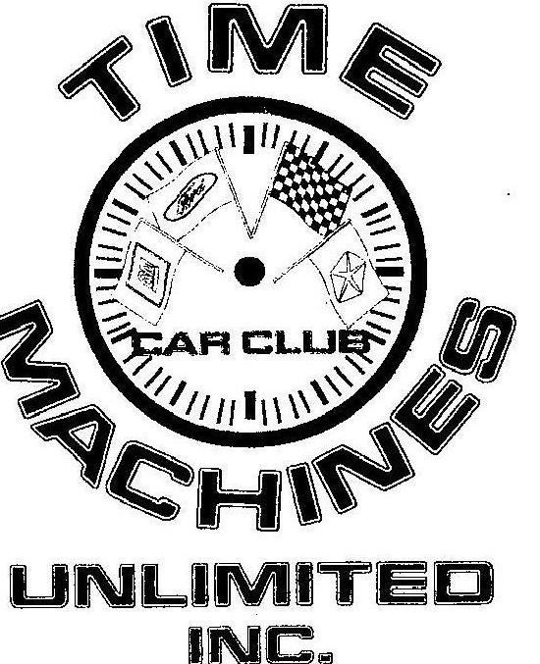
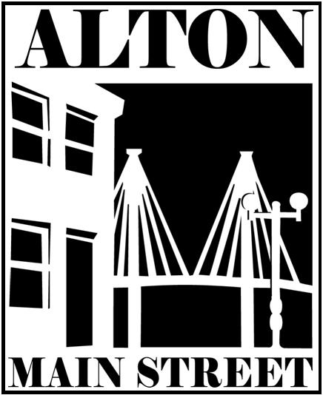
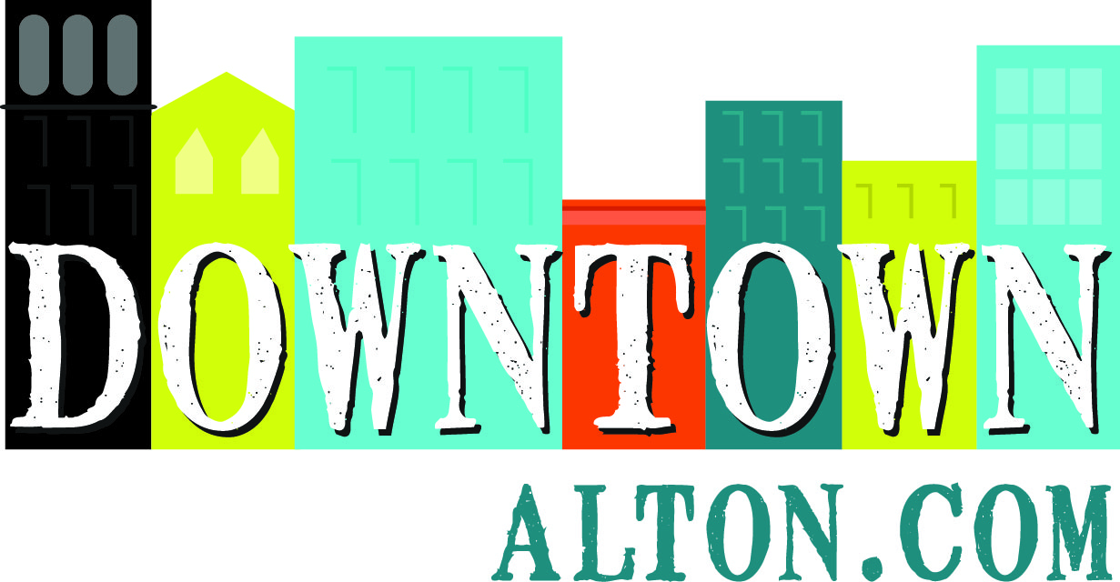
111 E. 4th Street – Suite 315
Alton, IL 62002
Phone: (618)-463-1016
sara@altonmainstreet.org
www.DowntownAlton.com

23rd Annual All-Wheels Drive-In Car Show

Dear Community Partner,

Alton Main Street and Time Machines Unlimited invite you to support and attend the 23rd Annual
All-Wheels Drive-In Car Show on Sunday, June 13th from 8am to 4pm. This premier show attracts 150-200 automobiles and draws 2,000+ spectators! We would appreciate your involvement in this popular event that brings the community to 3rd Street between State & Belle to experience the feeling of the “good ol’ days” where the streets are filled with classic cars & hot rods - plus music, street vendors and food trucks.

We hope you will take advantage of this opportunity to support a community tradition while also gaining great exposure for your business. We invite you to have a presence at the event and share information about your product or service with the public, which complements the community street festival experience.

Please indicate your sponsorship level (Deadline: May 21st!)

□ $50 BRONZE SPONSOR - Your company name will be featured on one class of trophies, and our DJ will announce a public thank you to your business three times during the Car Show.

□ $100 SILVER SPONSOR - Your company name will be featured on two classes of trophies, and our DJ will announce a public thank you to your business five times during the Car Show. Plus, your business will be welcome to set up booth space at the event to promote your business
&/or sell products, if desired.

□ $200 GOLD SPONSOR - Your company name will be featured on three classes of trophies, our DJ will announce a public thank you to your business ten times throughout the day, and you may set up booth space, if desired. Additionally, your company name will be listed on 150 insulated can coolers given to every car show registrant, and your company name or logo will be featured on posters and advertisements in print, radio and online media. (Please confirm ASAP for max exposure)

To reserve your space, please send this registration form along with a check payable to:
Alton Main Street (Attn: Car Show) 111 E. 4th Street – Suite 315 Alton, IL 62002

Business Name:______________________________ Contact Name:_________________________

Address:____________________________________ Website: _____________________________

City:______________________ State:__________________ Zip:___________________________

Phone:__________________________ Email: ___________________________________________

□ I would like to set up a booth at the event
Type of Info, Service or Goods:____________________________________________________
□ I would like to donate 150 promotional items for the car show registrant goodie bags

Thank you very much for considering being a sponsor; we look forward to hearing from you soon.
Sara McGibany – Executive Director, Alton Main Street & Jamey Griffin –Time Machines Auto Club
For more information: 618-463-1016 / sara@altonmainstreet.org, or visit www.DowntownAlton.com

Alton Main Street – engaging our community in the continued renewal of our historic downtown district and Mississippi River heritage by cultivating an attractive center of economic and social activity.

